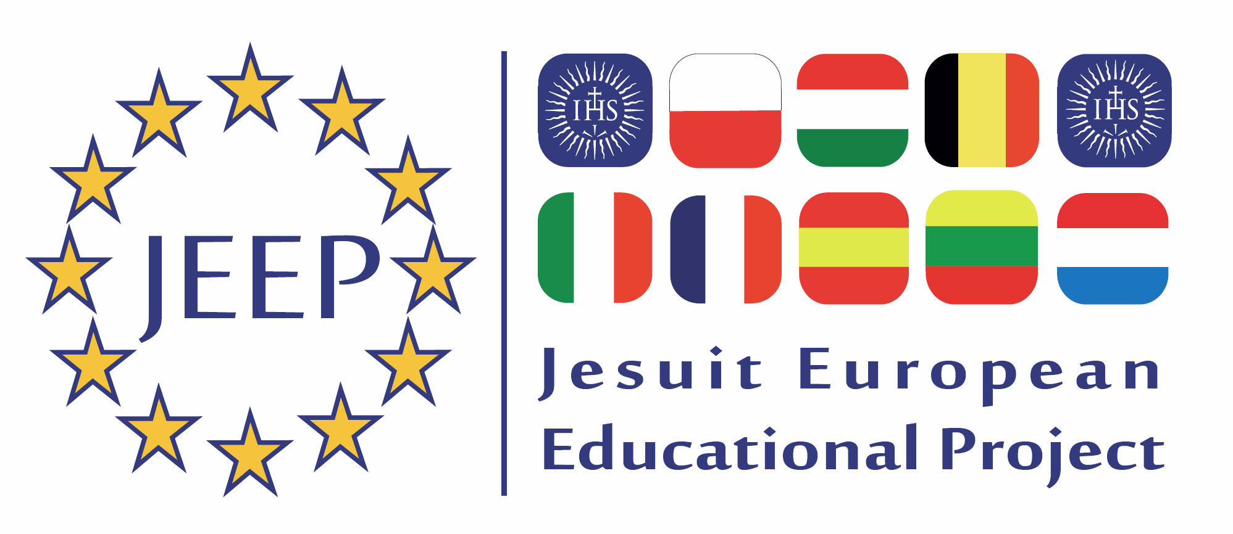

JEEP 2021
VIRTUAL EDITION, 8-12 MARCH 2021
Committee N°.1 Foreign Affairs.

Topic: The question of EU in relation to the Asian giant: China.

The EU and China established formal diplomatic ties in 1975 and today EU-China relations encompass an annual summit, regular ministerial meetings, and over 60 sectoral dialogues. The EU and China are committed to a comprehensive strategic partnership, as expressed in the EU-China 2020 Strategic Agenda for Cooperation. However, what kind of approach should the European Union take towards China during the upcoming decade?
- What could the European Union do in relation to human rights abuse and the lack of democracy in China? To what extent should Europe promote its values in the world?
- How should the European Union accommodate the interests of European countries in the present geopolitical climate? Which key role can the EU play between the main powers: USA, Russia, and China?
- How should the European Union take position in matters of defence, energy, or climate change? What should Europe's role be in a globalised world?
- How should the European Union ensure sustainable and transparent trade between EU and China according to international standards?
- How should the European Union develop a more balanced economic relationship with China? What will be the future of European trade in the next upcoming years?
- How do Chinese investments have an impact on Africa, and what could be the consequences for Europe?
Committee N°2 Women's Rights and Gender Equality
Topic: Gender violence in Europe
Gender-based violence is a phenomenon deeply rooted in gender inequality and continues to be one of the most notable human rights violations within all societies. Gender-based violence is violence directed against persons because of their gender. Both women and men experience gender-based violence but the majority of victims are women and girls.
In the European Union, one in three women have experienced physical and / or sexual violence since the age of 15 age and approximately 13 million women in the EU experience violence every year. Regarding these figures, how should the European Union fight against gender violence in Europe?

- Which main actions have to be taken to end this problem?
- How should the European Union react to the growing awareness of sexual harassment?
- Should the EU create a common legislation to face this problem? Are the European Institutions approaching it in an effective way?
- Should education follow this line of thought? Should the EU actively promote gender equality through schools?
- Considering the European Union’s power related to workplace issues, could it do more to ensure that progress is being made in combating the problem?
- Should the EU end the salary gap between men and women that still exists in the majority of the European countries?
- Which are the effects of the Istanbul Convention? Is the Istanbul Convention effective?

Committee N°3 Constitutional Affairs
Topic: The question of rising criticism and Euroscepticism related to the European Union.
In many members states the trust in the function and the role of the European Union is heavily criticized. Even the existence of the Union itself is frequently questioned. In the United Kingdom this scepticism and distrust even led to a vote for Brexit. In many other member states, the call for more national autonomy and reforms of the European Union grows every day. Taking into account this new context, how can the European Union regain its legitimacy?
- In which way should the European Union adapt or re-design itself to overcome the gap between European decision-making and its citizens?
- How can we explain the recent decline of trust in representative institutions of the EU in many of its Member States? Are citizens extrapolating their distrust in national institutions to the EU institutions?
- Are the institutions of the EU themselves subject to change?
- Are there other forms of European democratic participation possible?
- How can European leaders deal with the support of populist views?
- How could an ‘exit’ from other EU-countries be avoided? Should it be ‘strongly discouraged’ or is another EU possible, wished for?
- In which way is the increasing popularity of extreme right-parties related to lack of confidence in the European Institutions? Which principal measures can the European Union take to face this issue?
Committee N°4 Economic Affairs
Topic: The question of tax avoidance in the Europe Union.
Following revelations of large-scale tax abuse in the Panama Papers, the European Union released a blacklist of tax haven jurisdictions it will impose dissuasive sanctions on. However, critics point out that Member States such as Malta and Luxembourg benefit from policies that would be grounds for blacklisting in third countries. Considering this criticism and the ethical ramifications of large-scale avoidance, how should the European Union mitigate the economic cost of tax havens both within and outside the union?
- Which are the main causes and consequences of tax fraud in the European Union?
- Should the tax system be the same for all the European countries? Should the European Union remove the tax sovereignty of its Member States?
- How should the EU Member States ensure an effective tax system? In this sense, should the European Institutions develop tools for a most effective taxation policy? Should the fiscal union follow the monetary union of the European economies?
- Should the EU take the lead in the prosecution of tax law? Which main actions should be taken to end this fraud?
- What policies, instruments and initiatives at EU level are urgently necessary to support an almost equal tax system?
- In order to help the improvement of the European tax system, should the EU set up a banking union? How should it look like?
- What mechanisms could guarantee successful cooperation with international partners in the fight against tax avoidance?

Committee N°5 Civil Liberties, Justice and Home Affairs
Topic: Refugee crisis and the question of human rights.
Although the record high migratory flows to the EU witnessed during 2015 and 2016 had subsided by the end of 2017, sea arrivals remained at significant levels. In 2019-20 and in the years to come, considering the global effects of international and internal conflicts, climate change and the growing disparities between the EU and Third World countries, it is unlikely that migration will decrease. Considering this new reality, should the EU find ways to adjust to this and prepare for volatile forced migration flows?
- How can the EU establish refugee and asylum policies that address the diverse and conflicting attitudes in the member states? How should the issue of border control be handled?
- How can the EU assure that the burden-sharing of refugee and asylum seekers amongst Member States is guaranteed?
- How can peaceful societies be assured while considering the various perspectives of the diverse cultural, ethnic and religious groups?
- How could the European Union keep the numbers of asylum applications in its countries manageable, without violating human rights of incoming refugees?
- Should the EU take measures against refugee smugglers?
- Should the EU take measures against NGO’s helping refugees?
- With the increased number of refugees, asylum seeker and immigrant arrivals in the EU-member states during the last years, right wing populist movements have developed. This is, among other aspects, a consequence of the concern for ethnic and religious parallel societies. How can prosperous integration be achieved while ensuring the support of European citizens?

Committee N°6 Internal Market and Consumer Protection.
Topic: The question of cybersecurity and privacy in a globalized and connected world.
The global community is increasingly embracing ICT as key enabler for social and economic development. Governments across the world recognize that digital transformation has the power to further develop the prosperity and well-being of their citizens. In supporting this transformation, they also recognize that cybersecurity must be an integral and indivisible part of the technological progress.
In 2016, nearly one percent of all emails sent were essentially malicious attacks, the highest rate in recent years. Ransomware attacks increasingly affected businesses and consumers, with indiscriminate campaigns pushing out massive volumes of malicious emails. In May 2017, a massive cyberattack caused major disruptions to companies and hospitals in over 150 countries, prompting a call for greater cooperation around the world. In this new globalized and connected world, why does the EU need to act on cybersecurity?
- How can the EU establish a cyber and digital safety environment?
- Which are the main causes and consequences of cyber-attacks in the European Union? How the EU works to face cyber threats?
- Which measures could be taken by the European Union Agency for Network and Information Security (ENISA) to improve European cybersecurity?
- Which are the main implications of the Cybersecurity Act created by the European institutions? Which are its consequences for the European states?
- How is the EU-NATO cooperation on cybersecurity developing? What are its main consequences for the EU countries?
- Should the European Union educate in the correct use of IT devices and systems? What measures should the EU take to guarantee the safety of its citizens and the protection of basic human rights/civil liberties in a digital environment?

Committee N°7 Industry, Research and Energy
Topic: Climate change.
Climate change is an important global issue. Without action to reduce global greenhouse gas emissions, global warming is likely to exceed 2°C above pre-industrialised levels and could even be as much as 5°C by the end of the century. This would have a huge impact on the world's landscape and sea levels. Action to tackle climate change and cut greenhouse gas emissions is therefore a priority for the EU. EU leaders have committed to transform Europe into a highly energy-efficient, low carbon economy. However, is it possible to pursue economic development without endangering the planet?
- What can we do to promote sustainable development? How can the EU help low-income economies and fast-growing countries with their climate policy?
- What policy should the European Union adopt on the environment and renewable energy? Should the EU focus their policy on mitigation, adaptation, or a combination of both considering climate action? What are the consequences of a changing climate for EU citizens?
- Should the EU subsidize the development, production, and retail of green technologies? Should nuclear power be banned from European soil?
- What can we do to change people’s attitudes for a better climate? Is climate change an individual (i.e. changing people’s attitudes) or a collective (i.e. strong European policy) problem?
- What are the advantages and disadvantages of the EU Emissions Trading System? Should international aviation and shipping be included in the Trading System?

Committee N°8 Global Pandemics
Topic: Coronavirus crisis.
Coronaviruses are a type of virus. There are many different kinds of viruses, and some cause disease. A newly identified coronavirus, SARS-CoV-2, has caused a worldwide pandemic of respiratory illness, called COVID-19. COVID-19 appeared in Wuhan, a city in China, in December 2019. Although health officials are still tracing the exact source of this new coronavirus, early hypotheses thought it may be linked to a seafood market in Wuhan, China. Some people who visited the market developed viral pneumonia caused by the new coronavirus. A study that came out on Jan. 25, 2020, notes that the individual with the first reported case became ill on Dec. 1, 2019, and had no link to the seafood market. Investigations are ongoing as to how this virus originated and spread. Regarding this new reality, how should the EU face this new threat to the humanity?
- COVID-19 virus probably started in a “wet market” in Wuhan. Should the EU promote the prohibition of this markets around the world?
- How the European Union can be better prepared for the next pandemic? What actions need to be taken?
- Apple and Google are talking about using our phones to track the spread of COVID-19. Should the EU allow this measure? What measures should the EU take to guarantee the safety of its citizens and the protection of basic human rights/civil liberties? Why are human rights so important to the COVID-19 response?
- The EU must deal with the economic and social impact alongside the public health response. What economic and social policies should the European Union adopt?
- In this sense, inclusive responses to a global threat to ensure no one is left behind are essential. How can the European Union assure a global response? Should the European Union make the Covid19 vaccine mandatory for its citizens and residents?
- Emergency and security measures, if needed, must be temporary, proportional, and aimed at protecting people. Why are equality and non-discrimination important to the COVID-19 response? Why is global solidarity essential for the COVID-19 response?

